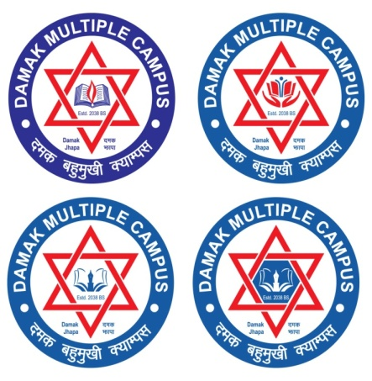

**Tribhuvan University**

**Faculty of Humanities and Social Sciences**

A Lab REPORT

Of

Advance Java

**Submitted to:**

**Department of Computer Application**

**Damak Multiple Campus**

***In partial fulfillment of the requirements for the Bachelors in Computer Application***

Submitted by

Sandip Chapagain

(TU Symbol No: 6-2-202-885-2019)

July, 2023

Under the Supervision of

Pradip Ghimire

**Acknowledgement**

The lab work report has been prepared in the partial fulfillment of course “**Advance Java**” of Sixth semester of Bachelor of art in computer application while preparing this report, I got a lot of co-operation and suggestion from different persons.

I am thankful to **Mr.Pradip Ghimire** (subject teacher) for properly guiding me. I also want to thank my friends who helps me a lot in the lab work.

I would like to express my hearty thanks to my family member who provided inspiration and motivation regularly for my success.

Sandip chapagain

Roll No:

TU Registration No: 6-2-0202-0885-2019

**CERTIFICATE**

This is to certify that **Mr.Sandip chapagain** has successful completed the lab work required for the partial fullfillment of the “**Advance Java**” under the guidance of subject teacher **Mr.Pradip Ghimire**

Subject Teacher:

Signature:

Date: